**INFOTRIXS INTERSHIP**

|  |  |
| --- | --- |
| **Domain** | CLOUD (AWS) |
| **Task** | Week 01 Task |
| **Name** | VIGNESH KUMAR S |
| **Contact Number** | +916382161356 |
| **Email id** | vigneshkumarselvkumar@gmail.com |
| **Website Hosted on Amazon S3** | <http://aws-infotrixs-task01.s3-website.us-east-2.amazonaws.com/> |

**WEEK 01 TASK:**

* Create a static website hosted on Amazon S3.
* Create a simple portfolio website using HTML and CSS, and host it on Amazon S3.
* Configure the necessary buckets, enable website hosting, and upload a basic HTML/CSS website.

**OVERALL PROCESS:**

1. Initially an Amazon S3 Bucket is created in the name **“**[aws-infotrixs-task01](https://s3.console.aws.amazon.com/s3/buckets/aws-infotrixs-task01?region=us-east-2)”. In the US East (Ohio) us-east-2 region and all the configurations are made so that the bucket can be accessible to the public

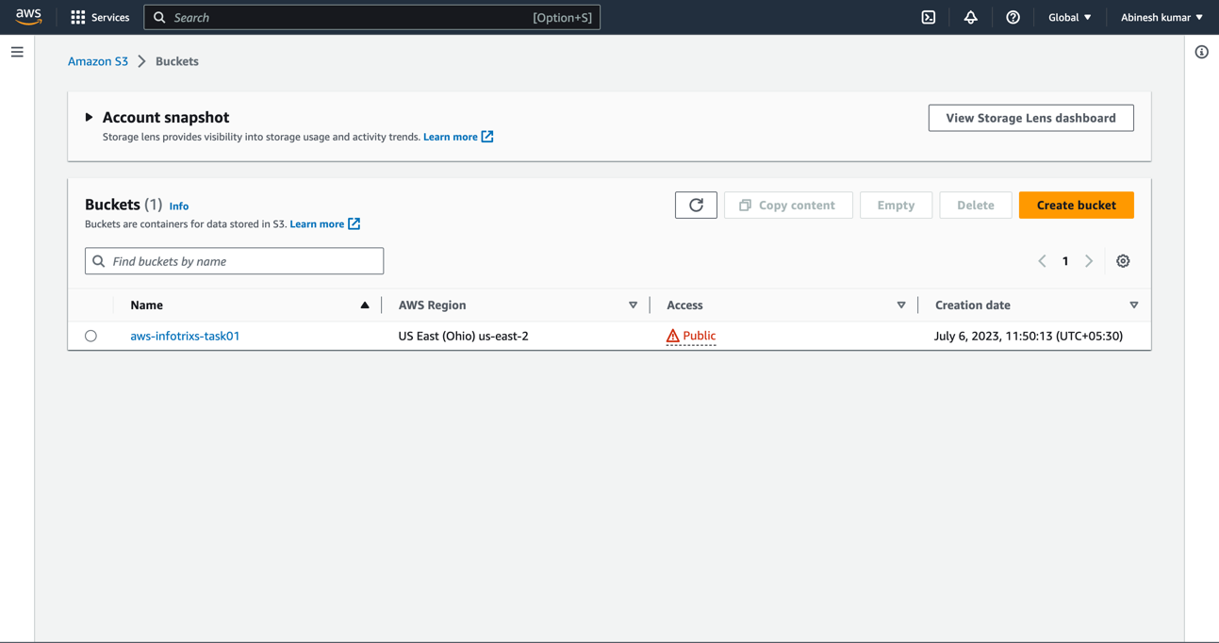

1. Then the Amazon S3 Bucket policies are configured so that the S3 Bucket is accessible to the public using the policy generator. Now the S3 bucket can be accessed by everyone.

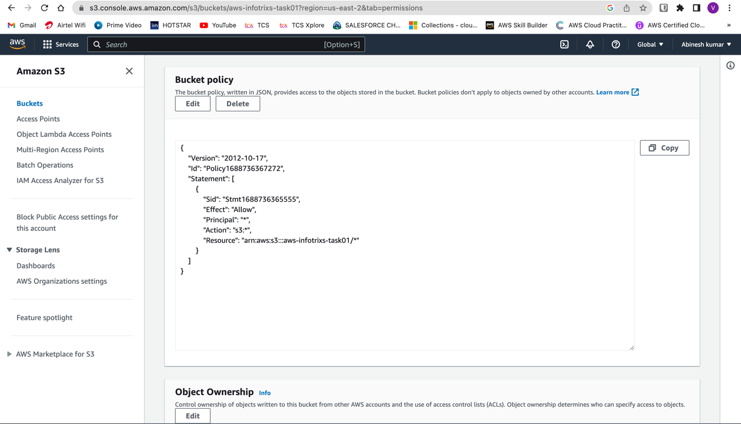

1. Then an Amazon S3 Object named [index1.html](https://s3.console.aws.amazon.com/s3/object/aws-infotrixs-task01?region=us-east-2&prefix=index1.html) is uploaded into the Amazon S3 Bucket so the website can be hosted on the internet.

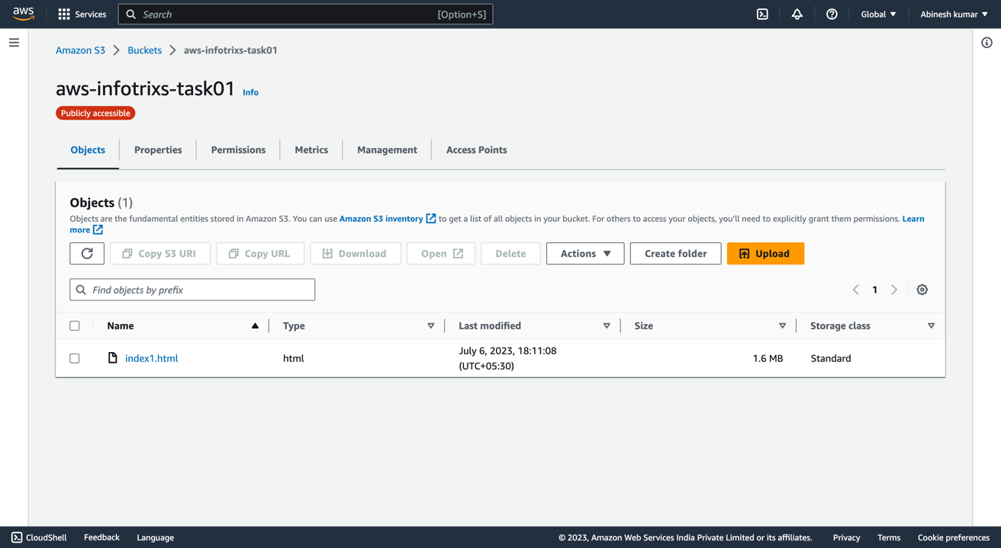

1. The [index1.html](https://s3.console.aws.amazon.com/s3/object/aws-infotrixs-task01?region=us-east-2&prefix=index1.html) file contains the HTML and CSS files that are required for the website.

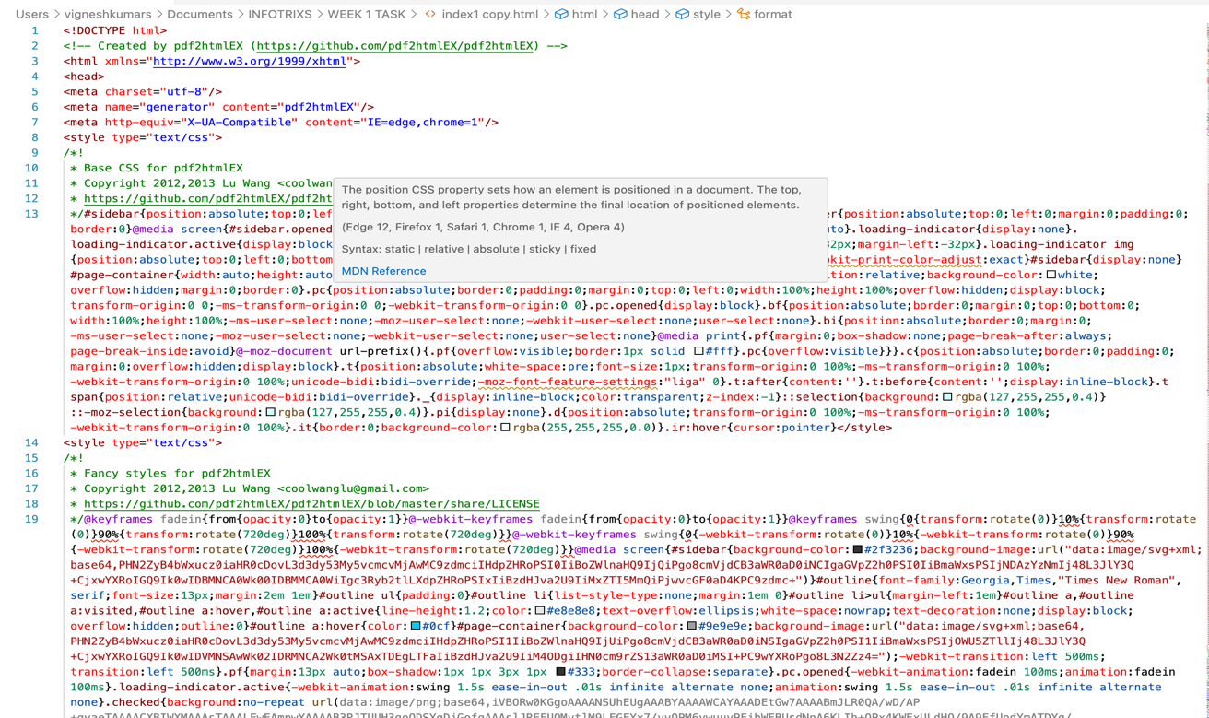

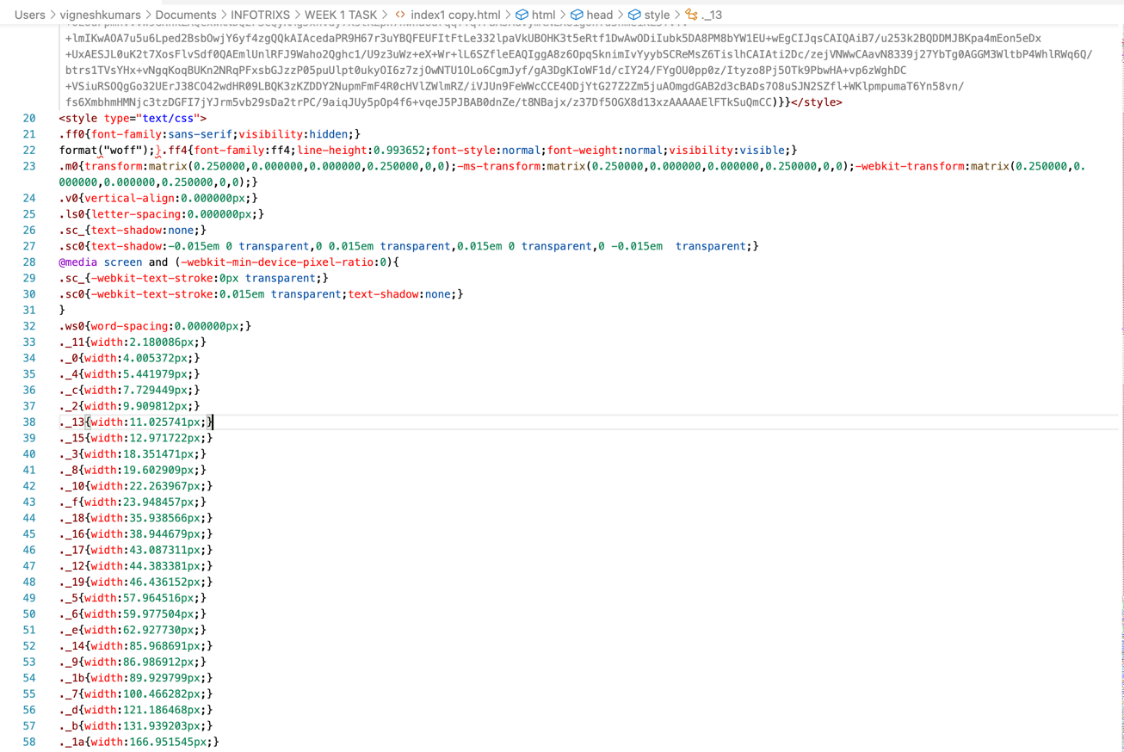

1. After uploading the object into the Amazon S3 Bucket, the Static Website Hosting is enabled with the type of Bucket Hosting in order to host the website on the Amazon S3. After this process a dedicated link in which the website is hosted on the Amazon S3 Bucket is displayed.

|  |  |
| --- | --- |
| Amazon S3 Website Hosted Link | <http://aws-infotrixs-task01.s3-website.us-east-2.amazonaws.com/> |

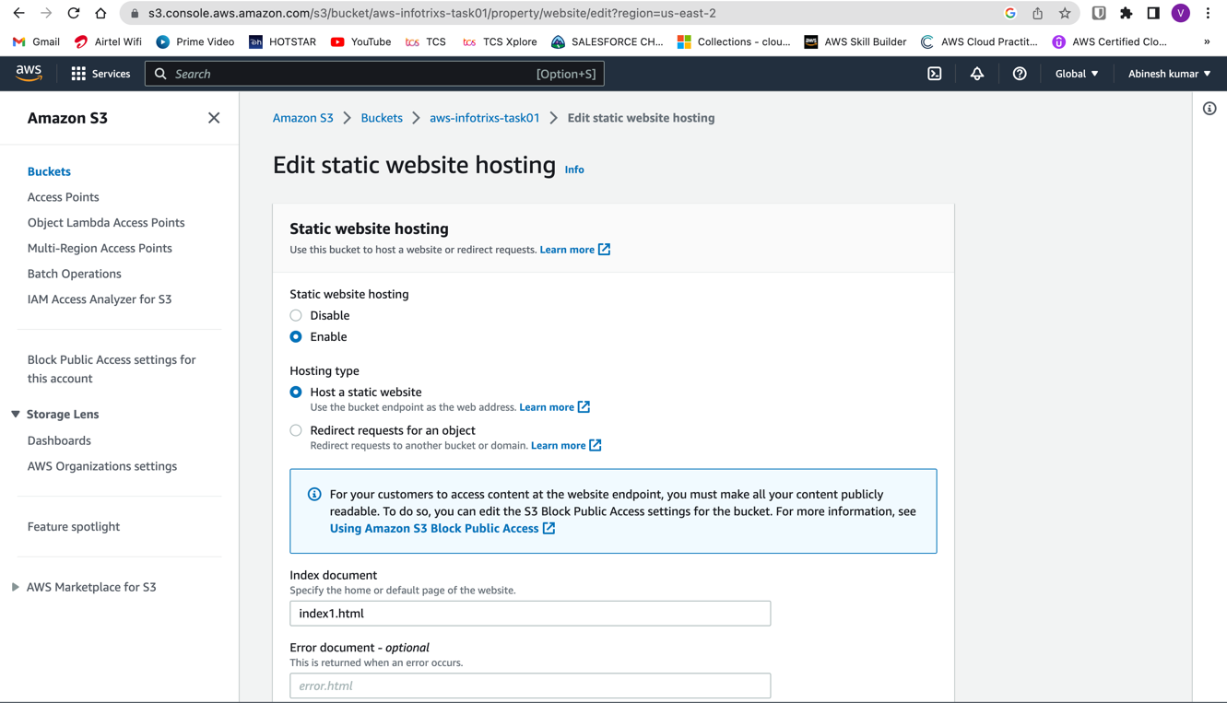

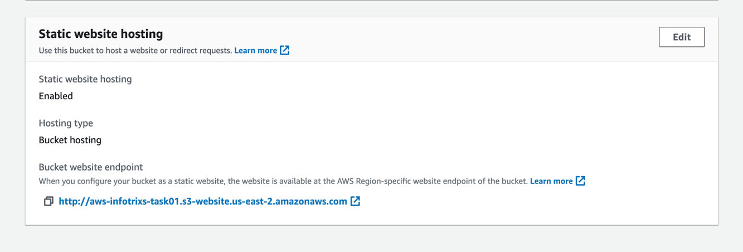

1. Finally the Website is hosted on the Amazon S3 and the website can be accessed all across the globe with the dedicated link provided by Amazon Web Services (AWS).



